**Name: Devvrat Miglani**

**Roll No. 37**

**Section: E3**

**Practical 3**

#include<stdio.h> #include<stdlib.h>

int q[20]; int front=0;int rear=-1; int data;

int isfull(){ if(rear==5){ printf("Queue is full\n");

}

return 0;

}

int isempty(){ if(front==rear){ printf("Queue is empty\n");

}

return 0;

}

void enqueue(int data){

if(isfull()){ printf("\n");

}

else

rear+=1; q[rear]=data;

}

void dequeue(){

if(isempty()) printf("\n");

else

front+=1;

data=q[front];

}

void main(){ enqueue(20); enqueue(31); enqueue(32); enqueue(33); enqueue(34); printf("After Insertion\n"); for(int i=front;i<=rear;i++){ printf("Inserted: %d\n", q[i]);

}

dequeue(); dequeue(); dequeue(); printf("After deletion\n"); for(int i=front;i<=rear;i++){ printf("Element are : %d\n", q[i]);}

}

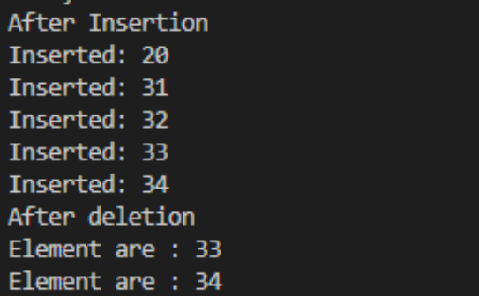

**Implementation**

#include <stdio.h>

#include <string.h> #define SIZE 50 char queue[SIZE]; char str[SIZE], revstr[SIZE]; int front = -1; int rear = -1; int i = 0;

void enqueue(char item)

{

if ((front == 0 && rear == SIZE - 1) || (front == rear + 1))

{

printf("Overflow\n"); return;

}

if (front == -1)

{

front = 0; rear = 0;

}

else if (front == 0) front = SIZE - 1; else front = front - 1; queue[front] = item;

}

void dequeue()

{

if (front == -1)

{

printf("Queue Underflow\n");

return;

}

revstr[i] = queue[front];

i++;

if (front == rear)

{

front = -1; rear = -1;

}

else if (front == SIZE - 1) front = 0; else front = front + 1;

}

int isEmpty()

{

if (front == -1) return 1; else return 0;

}

int isFull()

{

if ((front == 0 && rear == SIZE - 1) || (front == rear + 1))

{

return 1;

}

else

{

return 0;

}

}

int main()

{

printf("Enter the string :"); gets(str); for (int i = 0; i < strlen(str); i++)

{ if (!isFull())

{

enqueue(str[i]);

}

}

printf("Original: "); for (int i = 0; i < strlen(str); i++)

{

printf("%c", str[i]);

}

printf("\n"); for (int i = 0; i < strlen(str); i++)

{

if (!isEmpty())

{

dequeue();

}

}

printf("Reversed: "); for (int i = 0; i < strlen(str); i++)

{

printf("%c", revstr[i]);

}

printf("\n"); int val; for (int i = 0; i < strlen(str); i++)

{

if (str[i] != revstr[i])

{

val = 0; break;

}

else {

val = 1;

} }

if (val) printf("YES"); else printf("No"); return 0;

}

**Output:**

